Mishimoto Intake Hoses
- Direct fit for 2007–2009 Nissan 350Z
- Made of high grade silicone and heat-resistant embedded fibers
- Max temperature of 330°F
- Prevents increased temperatures in the intake charge
- Efficiently reduces heat
- Increases pressure tolerance
Mishimoto proudly introduces its Nissan 350Z Silicone Air Intake Hose Kit! The 350Z silicone air intake hoses are made with a combination of high grade silicone and heat-resistant embedded fibers to prevent increased temperatures in the intake charge caused by excess radiant heat in the engine bay. Preventing increased intake charge temperatures will ultimately increase horsepower and provide improved performance. The air intake hose is the perfect replacement for the OEM intake piping. The Nissan 350Z Silicone Air Intake Hose Kit is available in black, blue and red, and features (4) Mishimoto T-Bolt clamps for easy installation.

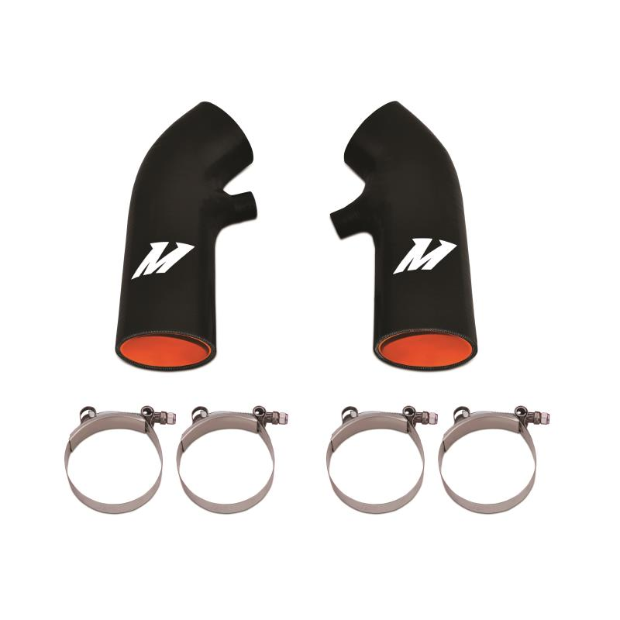
Ordered on January 21, 2018 Order# 112-8983284-5382604
View or Print invoice

Payment Method
**** 9744

Order Summary
Item(s) Subtotal:
$112.52
Shipping & Handling:
$0.00
Total before tax:
$112.52
Estimated tax to be collected:
$0.00
Grand Total:
$112.52
See tax and seller information
Transactions
Arriving Jan 25 - Jan 30
Track package
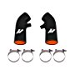

Order Summary
Item(s) Subtotal:
125.95
Shipping & Handling:
$0.00
Total before tax:
$125.95
Estimated tax to be collected:
$0.54
Grand Total:
$126.49

